**ECA14 – Embedded System**

**List of Experiments**

|  |  |  |
| --- | --- | --- |
| **S. No** | **Name of the Experiment** | **Remarks** |
| **1** | Study Of Keil And Proteusmicro Vision |  |
| **2** | Blinking Of Led Using 8051 Microcontroller Using Keil And Proteus |  |
| **3** | Generation Of Square Wave Using Keil And Proteus |  |
| **4** | Fade In Fade Out Of Led Using 8051 Using Keil And Proteus |  |
| **5** | Stepper Motor Using 8051 Using Keil And Proteus |  |
| **6** | Interfacing Of Relay Using 8051 Using Keil And Proteus |  |
| **7** | Led Toggle Using 8051 Using Keil And Proteus |  |
| **8** | 7 Segment Display Using 8051 Using Keil And Proteus |  |
| **9** | Led Chaser Using 8051 Using Keil And Proteus |  |
| **10** | Study of ARM Processor |  |
| **11** | Write and execute C program to blink LEDs using software delay routine in LPC2148 kit |  |
| **12** | Write and execute C program to read the switch and display in the LEDs using LPC2148 kit |  |
| **13** | Write and execute C program to display a number in seven segment LED in LPC2148 kit |  |
| **14** | Write and execute C program for serial transmission and reception using on-chip UART in LPC2148 kit. |  |
| **15** | Write and execute C program for accessing an internal ADC and display the binary output in LEDS in LPC2148 kit. |  |

Experiment no -01

**Study of Keil and ProteusMicro Vision**

**Keil MicroVision** is a free software which solves many of the main points for an embedded program developer. This software is an integrated development environment (IDE), which integrated a text editor to write programs, a compiler and it will convert your source code to hex files too. μVision4 introduces a flexible window management system, enabling us to drag and drop individual windows anywhere on the visual surface including support for Multiple Monitors.

**KEIL PROCEDURE:**

1. Open the software, Click on project and open new version project.

2. Create a new project file

3. Enter AT89C51

4. Click NO

5. Click [Ctrl +N] and Type the code

6. Open project and click Build target

7. Open Build target and open source file and ADD, CLOSE

8. Click build target

9. Next debug start and stop

10. Open peripherals and select port 2

11. Now run the program in Debug

12. Open project and click optional properties and in that give output as hex file.

13. Create hex file.

**PROTEUS PROCEDURE:**

* Open proteus by clicking run as administrator.
* Open new project and enter the file name.
* Click next, next, next and finish.
* Click P symbol and search keyword and place the required components
* Now connect the components as required
* Give input to AT89C51 as HEX file.
* Start the simulation process

Experiment 02

**BLINKING OF LED USING 8051 MICROCONTROLLER USING KEIL AND PROTEUS**

**AIM:**

To Write an assembly language program to LED blink using 8051

**SOFTWARES REQUIRED:**

* Keil software

**PROGRAM**

ORG 0000H

UP: SETB P2.0

ACALL DELAY

CLR P2.0

ACALL DELAY

SJMP UP

DELAY: MOV R4,#35

H1:MOV R3,#255

H2:DJNZ R3,H2

DJNZ R4,H1

RET

END

**CIRCUIT DIAGRAM:**

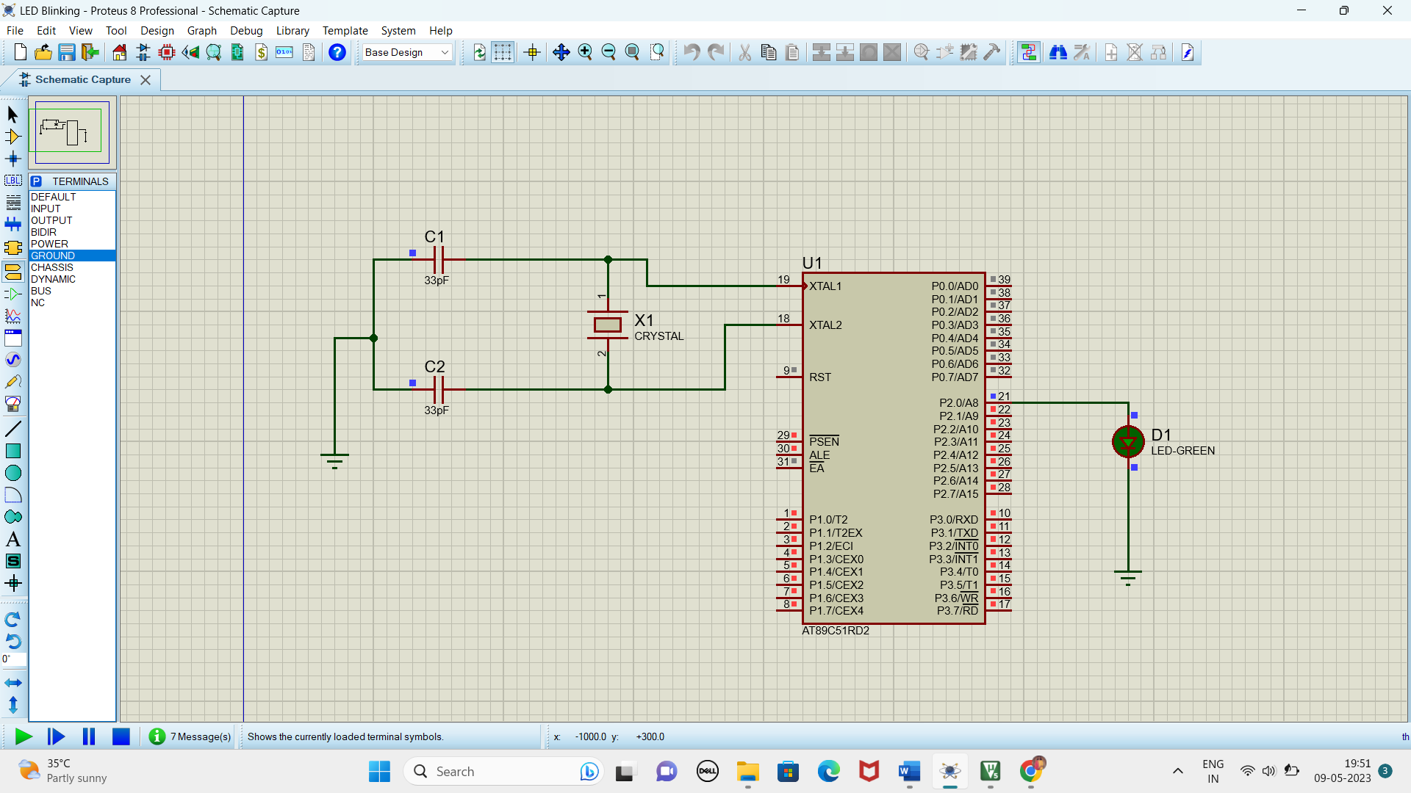

**RESULT**

Thus the program has been successfully verified and executed.

Experiment 3

**GENERATION OF SQUARE WAVE USING KEIL AND PROTEUS**

**AIM:**

Write an assembly language program to Generate square wave using 8051.

**SOFTWARE REQUIRED:**

* Keil software.
* Proteus 8 software.

**PROGRAM**

ORG 0000H

UP: SETB P2.0

ACALL DELAY

CLR P2.0

ACALL DELAY

SJMP UP

DELAY: MOV R4,#35

H1:MOV R3,#255

H2:DJNZ R3,H2

DJNZ R4,H1

RET

END

**CIRCUIT DIAGRAM:**

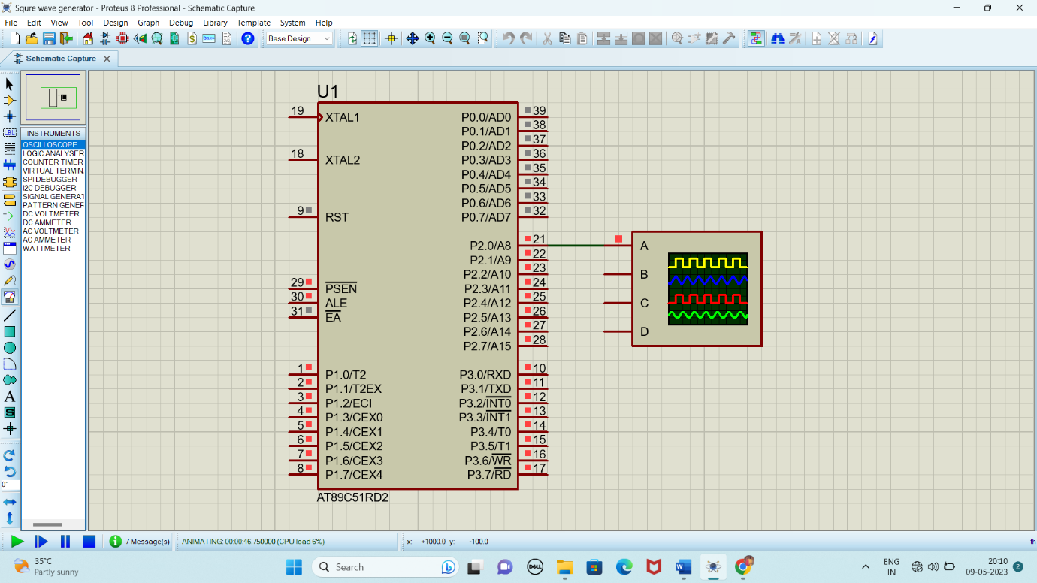

**OUTPUT:**

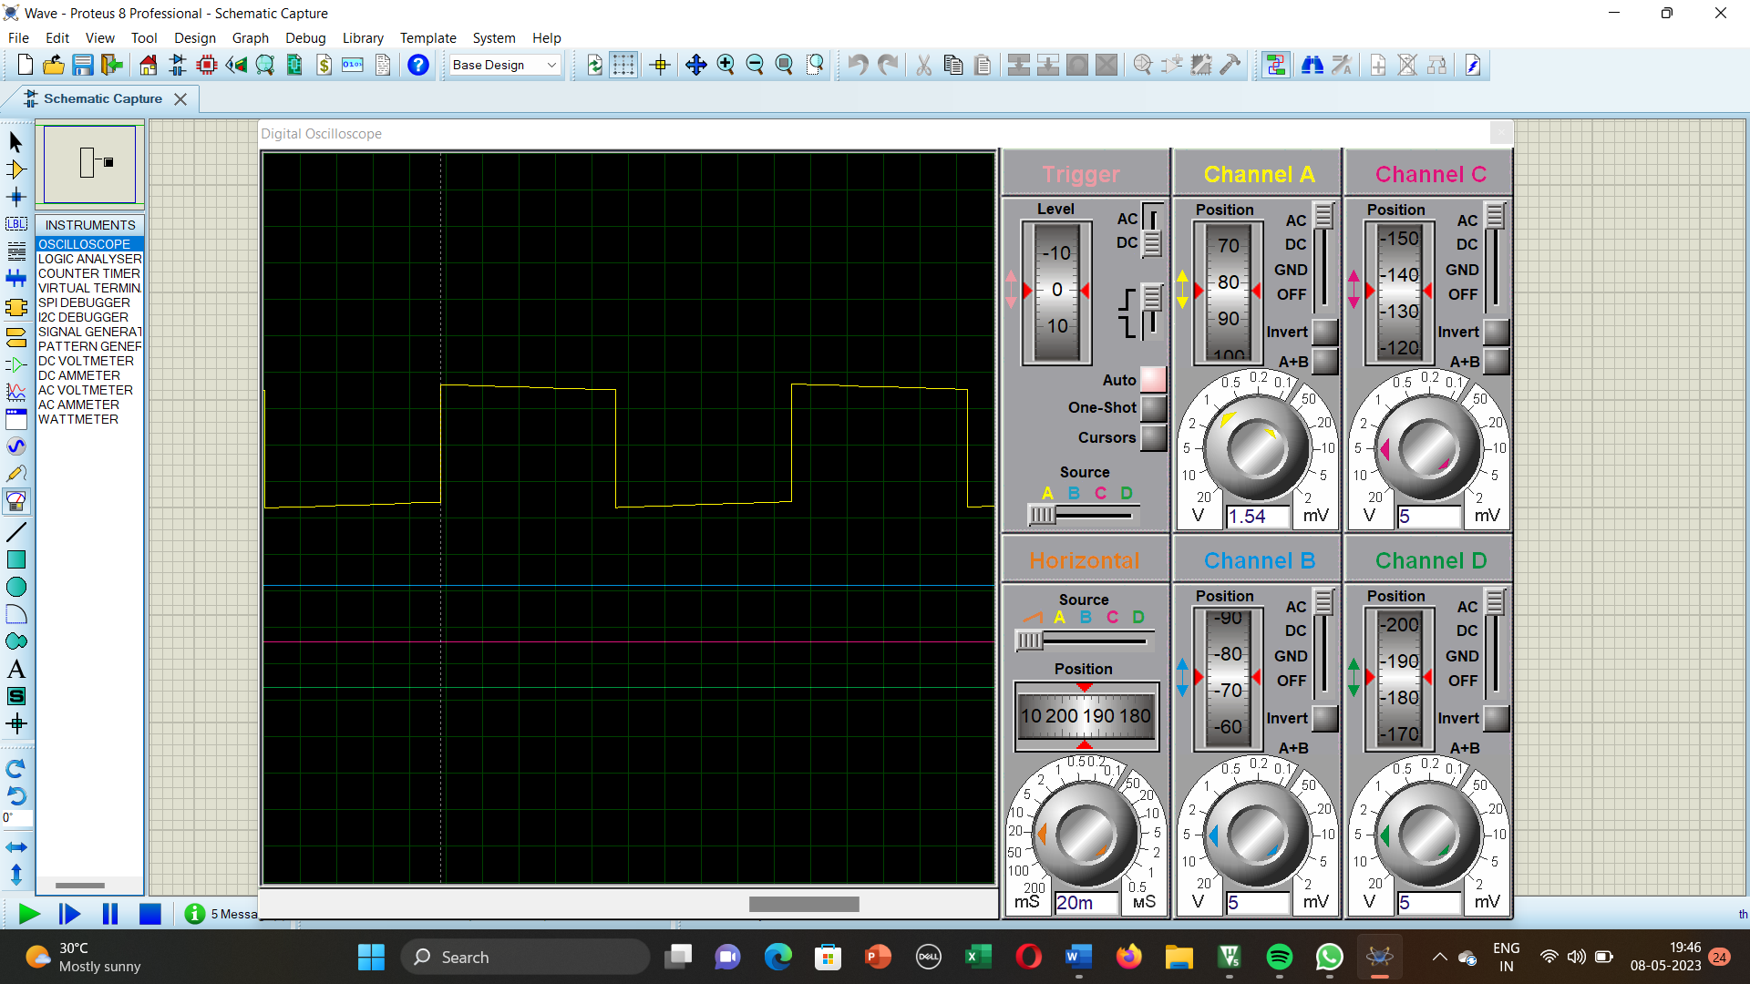

**RESULT:**

Thus the program has been successfully verified and executed.

Experiment 4

**FADE IN FADE OUT OF LED USING 8051 USING KEIL AND PROTEUS**

**AIM:**

Write an assembly language program for Fade in Fade out of LED Using 8051 using Keil and Proteus

**SOFTWARE REQUIRED:**

* Keil software 5.
* Proteus 8 software.

**PROGRAM:**

#include <REGX52.h>

delay(unsigned int y)

{

unsigned int i,j;

for(i=0;i<y;i++)

{

for(j=0;j<1275;j++){}

}

}

main()

{

while(1)

{

delay(100);

P1_0 = 0;

delay(100);

P1_0 = 1;

}

}

**CIRCUIT DIAGRAM:**

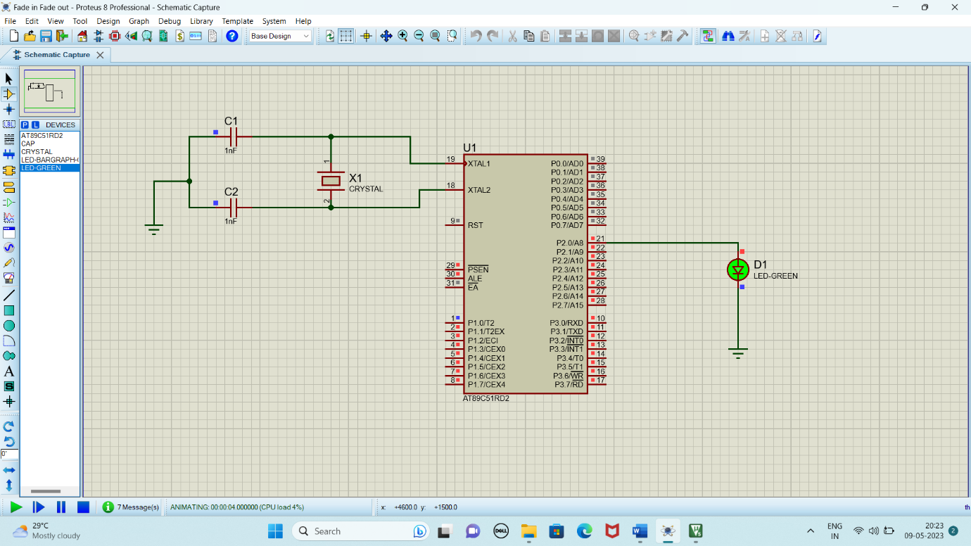

**RESULT:**

Thus the program has been successfully verified and executed.

Experiment 5

**STEPPER MOTOR USING 8051 USING KEIL AND PROTEUS**

**AIM:**

Write an assembly language program for Stepper Motor Using 8051 using Keil and Proteus

**SOFTWARE REQUIRED:**

* Keil software 5.
* Proteus 8 software.

**PROGRAM:**

ORG 0000H

UP: MOV P2,#09H

ACALL DELAY

MOV P2,#0CH

ACALL DELAY

MOV P2,#06H

ACALL DELAY

MOV P2,#03H

ACALL DELAY

SJMP UP

DELAY:MOV R4,#18

H1:MOV R3,#255

H2:DJNZ R3,H2

DJNZ R4,H1

RET

END

**Circuit Diagram:**

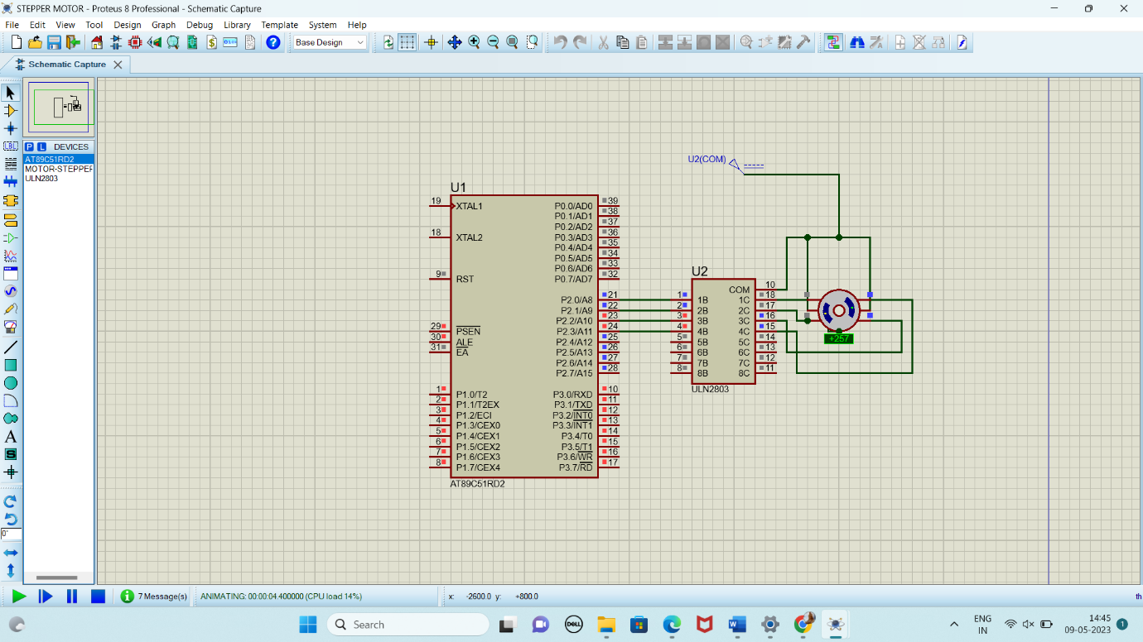

**RESULT:**

Thus the program has been successfully verified and executed.

Experiment 6

**INTERFACING OF RELAY USING 8051 USING KEIL AND PROTEUS**

**AIM:**

Write an assembly language program for Interfacing of Relay Using 8051 using Keil and Proteus

**SOFTWARE REQUIRED:**

* Keil software 5.
* Proteus 8 software.

**PROGRAM:**

ORG 0000H

UP:SETB P2.0

ACALL DELAY

CLR P2.0

ACALL DELAY

SJMP UP

DELAY:MOV R4,#18

H1:MOV R3,#255

H2:DJNZ R3,H2

DJNZ R4,H1

RET

END

**CIRCUIT DIAGRAM:**

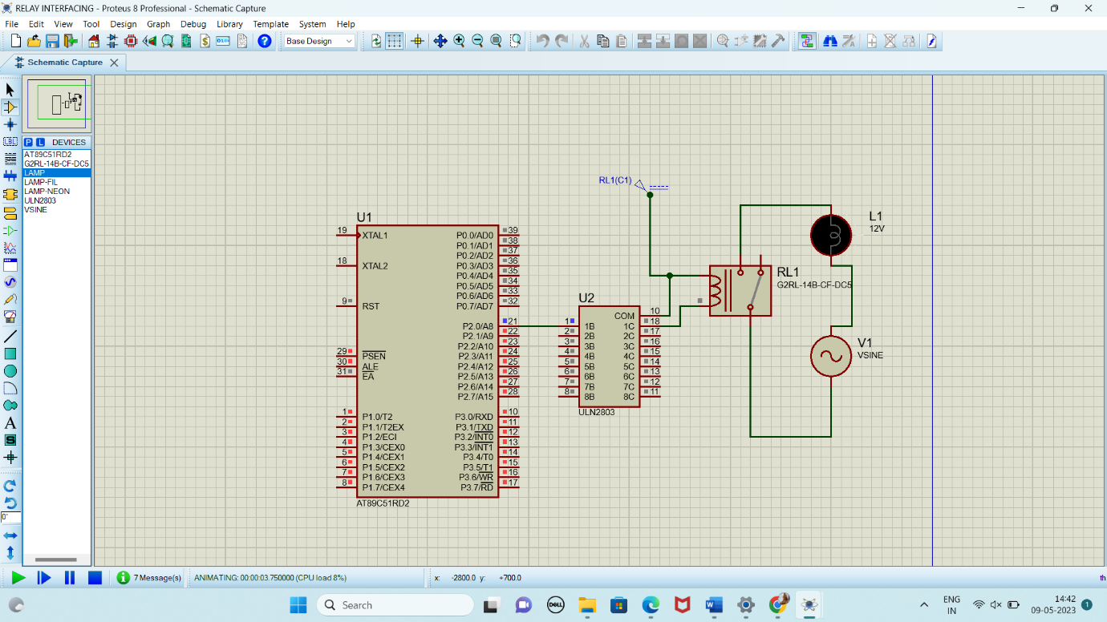

**RESULT:**

Thus the program has been successfully verified and executed.

Experiment 7

**LED TOGGLE USING 8051 USING KEIL AND PROTEUS**

**AIM:**

Write an assembly language program for LED Toggle Using 8051 using Keil and Proteus

**SOFTWARE REQUIRED:**

* Keil software 5.
* Proteus 8 software.

**PROGRAM:**

ORG 0000H

UP: MOV P2,#55H

ACALL DELAY

MOV P2,#0AAH

ACALL DELAY

SJMP UP

DELAY:MOV R4,#10

H1:MOV R3,#255

H2:DJNZ R3,H2

DJNZ R4,H1

RET

END

**CIRCUIT DIAGRAM:**

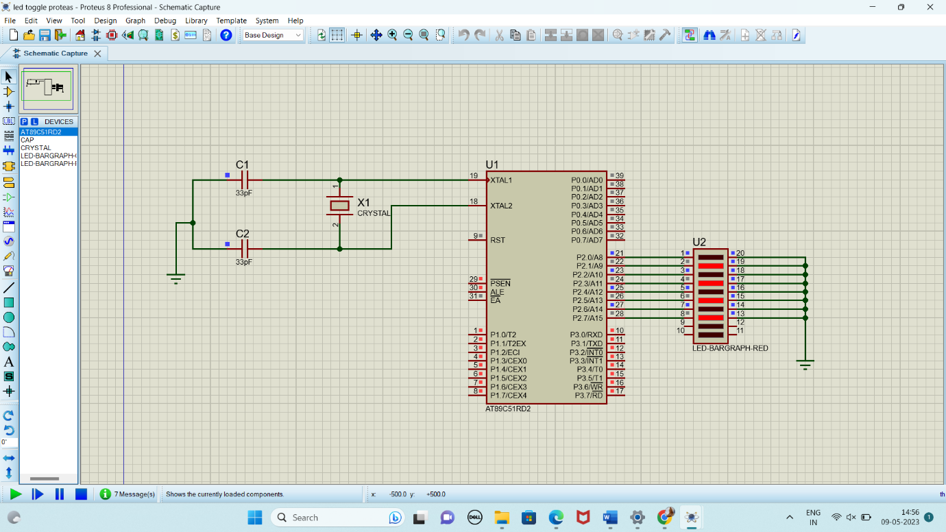

**RESULT:**

Thus the program has been successfully verified and executed.

Experiment 8

**7 SEGMENT DISPLAY USING 8051 USING KEIL AND PROTEUS**

**AIM:**

Write an assembly language program for 7 Segment Display Using 8051 using Keil and Proteus

**SOFTWARE REQUIRED:**

* Keil software 5.
* Proteus 8 software.

**PROGRAM:**

ORG 000H

UP:MOV P2,#0C0H

ACALL DELAY

MOV P2,#0F9H

ACALL DELAY

MOV P2,#0A4H

ACALL DELAY

MOV P2,#0B0H

ACALL DELAY

MOV P2,#99H

ACALL DELAY

MOV P2,#92H

ACALL DELAY

MOV P2,#82H

ACALL DELAY

MOV P2,#0F8H

ACALL DELAY

MOV P2, #80H

ACALL DELAY

MOV P2,#90H

ACALL DELAY

DELAY: MOV R5,#10

H1:MOV R4,#180

H2:MOV R3,#255

H3:DJNZ R3,H3

DJNZ R4,H2

DJNZ R5,H1

RET

END

**CIRCUIT DIAGRAM:**

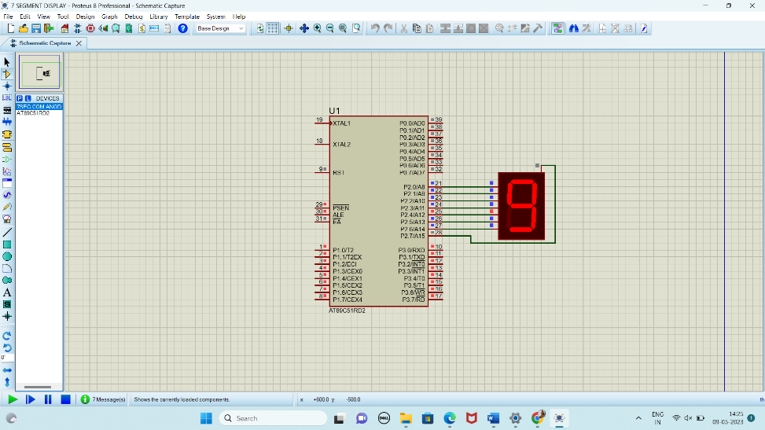

**RESULT:**

Thus the program has been successfully verified and executed.

Experiment 9

**LED CHASER USING 8051 USING KEIL AND PROTEUS**

**AIM:**

Write an assembly language program for LED Chaser Using 8051 using Keil and Proteus

**SOFTWARE REQUIRED:**

* Keil software 5.
* Proteus 8 software.

**PROGRAM:**

ORG 0000H

UP: MOV P2,#01H

ACALL DELAY

MOV P2,#02H

ACALL DELAY

MOV P2,#04H

ACALL DELAY

MOV P2,#08H

ACALL DELAY

MOV P2,#10H

ACALL DELAY

MOV P2,#20H

ACALL DELAY

MOV P2,#40H

ACALL DELAY

MOV P2,#80H

ACALL DELAY

SJMP UP

DELAY: MOV R4,#255

H1: DJNZ R4,H1

RET

END

**CIRCUIT DIAGRAM:**

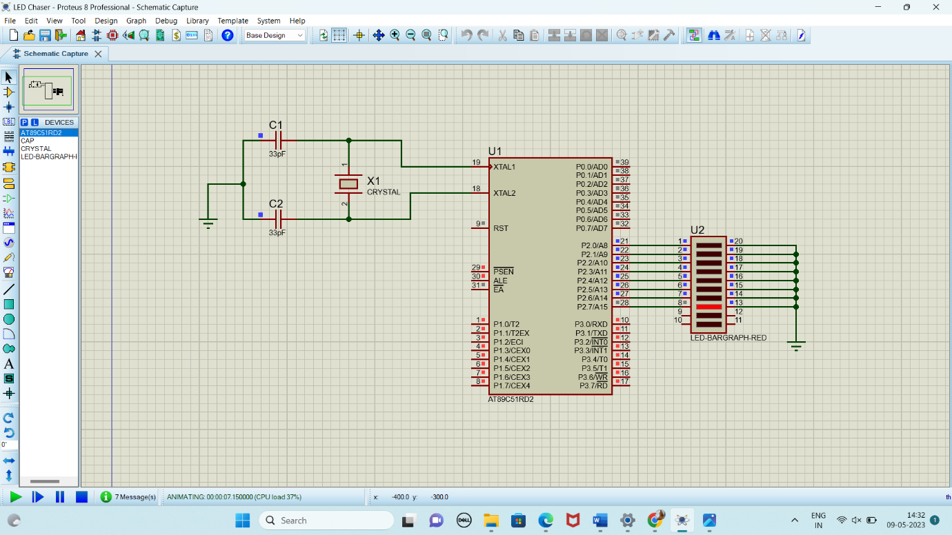

**RESULT:**

Thus the program has been successfully verified and executed.

**Exp. STUDY OF ARM PROCESSOR**

**Date:**

**Aim:**

To study the architecture and working of an ARM processor.

**Component Required:**

* ARM LPC2148

**Theory:**

ARM is a family of instruction set architectures for computer processors based on a reduced instruction set computing (RISC) architecture developed by British company ARM Holdings. A RISC-based computer design approach means ARM processors require significantly fewer transistors than typical processors in average computers. This approach reduces costs, heat and power use. These are desirable traits for light, portable, battery-powered devices—including smartphones, laptops, tablet and notepad computers), and other embedded systems. A simpler design facilitates more efficient multi-core CPUs and higher core counts at lower cost, providing higher processing power and improved energy efficiency for servers and supercomputers.

**Features of LPC214x Series Controllers:**

* 8 to 40 kB of on-chip static RAM and 32 to 512 kB of on-chip flash program memory.128 bit wide interface/accelerator enables high speed 60 MHz operation.
* In-System/In-Application Programming (ISP/IAP) via on-chip boot-loader software. Single flash sector or full chip erase in 400 ms and programming of 256 bytes in 1ms.
* Embedded ICE RT and Embedded Trace interfaces offer real-time debugging with the on-chip Real Monitor software and high speed tracing of instruction execution.
* USB 2.0 Full Speed compliant Device Controller with 2 kB of endpoint RAM. In addition, the LPC2146/8 provides 8 kB of on-chip RAM accessible to USB by DMA.
* One or two (LPC2141/2 vs. LPC2144/6/8) 10-bit A/D converters provide a total of 6/14analog inputs, with conversion times as low as 2.44 us per channel.
* Single 10-bit D/A converter provides variable analog output.
* Two 32-bit timers/external event counters (with four capture and four compare channels each), PWM unit (six outputs) and watchdog.
* Low power real-time clock with independent power and dedicated 32 kHz clock input.
* Multiple serial interfaces including two UARTs (16C550), two Fast I2C-bus (400 kbit/s), SPI and SSP with buffering and variable data length capabilities.
* Vectored interrupt controller with configurable priorities and vector addresses.
* Up to 45 of 5 V tolerant fast general purpose I/O pins in a tiny LQFP64 package.
* Up to nine edge or level sensitive external interrupt pins available.
* On-chip integrated oscillator operates with an external crystal in range from 1 MHz to30 MHz and with an external oscillator up to 50 MHz.
* Power saving modes include Idle and Power-down.
* Individual enable/disable of peripheral functions as well as peripheral clock scaling for additional power optimization.
* Processor wake-up from Power-down mode via external interrupt, USB, Brown-Out Detect (BOD) or Real-Time Clock (RTC).
* Single power supply chip with Power-On Reset (POR) and BOD circuits – CPU operating voltage range of 3.0 V to 3.6 V (3.3 V ± 10 %) with 5 V tolerant I/O pads.

LPC2148 needs the following hardware to work properly:

* Power Supply
* Crystal Oscillator
* Reset Circuit
* RTC crystal oscillator
* UART

*Power Supply*

LPC2148 works on 3.3 V power supply. LM 117 can be used for generating 3.3 V supply. However, basic peripherals like LCD, ULN 2003 (Motor Driver IC) etc. works on 5V. So AC mains supply is converted into 5V using below mentioned circuit and after that LM 117 is used to convert 5V into 3.3V.

*Reset Circuit*

Reset button is essential in a system to avoid programming pitfalls and sometimes to manually bring back the system to the initialization mode. MCP 130T is a special IC used for providing stable RESET signal to LPC 2148.

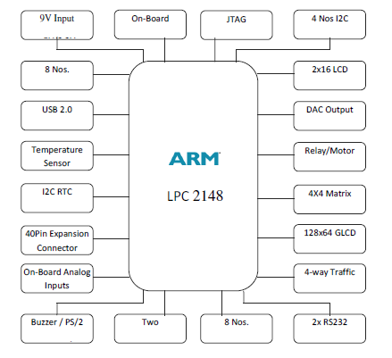

**Figure - 3.1:** ARM Processor

*Flash Programming Utility*

NXP Semiconductors produce a range of Microcontrollers that feature both on-chip. Flash memory and the ability to be reprogrammed using In-System Programming technology.

**On-board Peripherals**

• 8-Nos. of Point LED’s (Digital Outputs)

• 8-Nos. of Digital Inputs (Slide Switch)

• 2 Lines X 16 Character LCD Display

• I2C Enabled 4 Digit Seven-Segment Display

• 128x64 Graphical LCD Display

• 4 X 4 Matrix keypad

• Stepper Motor Interface

• 2 Nos. Relay Interface

• Two UART for Serial Port Communication through PC

• Serial EEPROM

• On-chip Real Time Clock with Battery Backup

• PS/2 Keyboard Interface (Optional)

• Temperature Sensor

• Buzzer (Alarm Interface)

• Traffic Light Module (Optional)

**Pin Configuration**

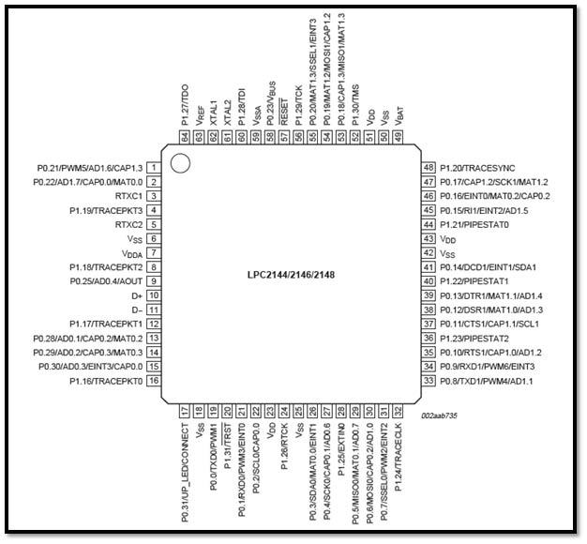

**Result:**

The ARM processor has been studied successfully.

**Exp.**

**Write and execute C program to blink LEDs using software delay routine in LPC2148 kit**

**Date:**

**Aim:** To write and execute a C program to blink LEDs using software delay routine in LPC 2148 kit

**Apparatus Required:**

Keil uVision5 Software

Philips Flah Programmer

LPC 2148 kit

**Program:**

#include "lpc214x.h"

void delay (unsigned int k);

void main(void)

{

IODIR0 = 0xFFFFFFFF; //Configure Port0 as output Port

PINSEL0 = 0; //Configure Port0 as General Purose IO

while(1)

{

IOSET0 = 0x0000ff00; //Set P0.15-P0.8 to '1'

delay(1000); //1 sec Delay

IOCLR0 = 0x0000ff00; //Set P0.15-P0.8 to '0'

delay(1000); //1 Sec Delay

}

}

//Delay Program

//Input - delay value in milli seconds

void delay(unsigned int k)

{

unsigned int i,j;

for (j=0; j<k; j++)

for(i = 0; i<=800; i++);

**Output:** LEDs P0.15-P0.8 are blinking

**Result:**

Thus the C program to blink LEDs using software delay routine was written and executed in LPC 2148 kit

**Exp.**

**Write and execute C program to read the switch and display in the LEDs using LPC2148 kit**

**Date:**

**Aim:**  To write and execute C program to read the switch and display in the LEDs using LPC2148 kit

**Apparatus Required:**

Keil uVision5 Software

Philips Flah Programmer

LPC 2148 kit

**Program:**

#include "lpc214x.h"

int main(void)

{

unsigned int sw_sts;

IODIR0 = 0x0000ff00; //Configure Port0

PINSEL0 = 0; //Configure Port0 as General Purose IO

while(1)

{

sw_sts = IOPIN0;

IOSET0 = 0x0000ff00; //Set P0.15-P0.8 to '1'

IOCLR0 = sw_sts >> 8; //Set P0.15-P0.8 to '0'

}

}

Output: LEDs P0.15-P0.08 displayed the bits entered in the switches

Result:

Thus C program was written read the switch and display in the LEDs using LPC2148 kit

**Exp.**

**Write and execute C program to display a number in seven segment LED in LPC2148 kit**

**Date:**

**Aim:** To write and execute C program to display a number in seven segment LED in LPC2148 kit

**Apparatus Required:**

Keil uVision5 Software

Philips Flah Programmer

LPC 2148 kit

**Program:**

//SEVEN SEGMENT LED DISPLAY INTERFACE IN C

/* Program to Count 0-9 and Display it in 7 segment Display (MUX) DS4

* Display Select DS3 ==> "P0.13" Enable --> '0', Disable --> '1'

* Display Select DS4 ==> "P0.12" Enable --> '0', Disable --> '1'

*/

/* Segment Connection Display 1 & 2 Enable --> '1', Disable --> '0'

*--------------------------------------------------------------------

* MSB LSB

* Dp G F E D C B A

* P0.23 P0.22 P0.21 P0.20 P0.19 P0.18 P0.17 P0.16

* 0 0 0 0 0 1 1 0 --> 6 => '1'

*---------------------------------------------------------------------*/

#include <LPC214X.H>

#define DS3 1<<13 // P0.13

#define DS4 1<<12 // P0.12

#define SEG_CODE 0xFF<<16 // Segment Data from P0.16 to P0.23

unsigned char const seg_dat[]={0x3F, 0x6, 0x5B, 0x4F, 0x66, 0x6D, 0x7D, 0x7, 0x7F, 0x67};

void delayms(int n)

{

int i,j;

for(i=0;i<n;i++)

{for(j=0;j<5035;j++) //5035 for 60Mhz ** 1007 for 12Mhz

{;}

}

}

int main (void)

{

unsigned char count;

PINSEL0 = 0; // Configure Port0 as General Purpose IO => P0.0 to P0.15

PINSEL1 = 0; // Configure Port0 as General Purpose IO => P0.16 to P0.31

IODIR0 = SEG_CODE | DS3 | DS4; //Configure Segement data & Select signal as output

IOSET0 = SEG_CODE | DS3 ; //Disable DS3 display

IOCLR0 = DS4; //Enable DS4 Display

count = 0; //Initialize Count

//Display Count value

IOCLR0 = SEG_CODE;

IOSET0 = seg_dat[count]<<16;

while(1)

{

delayms(1000); //1 sec delay

count++; //Increment count

if(count>9) count=0; //Limit 0-9

//Display Count value

IOCLR0 = SEG_CODE;

IOSET0 = seg_dat[count]<<16;

}

}

**Output:** 7-Segment display counting from 0 to 9

**Result:**

Thus C program, was written and executed to display a number in seven segment LED in LPC2148 kit

**Exp.**

**Write and execute C program for serial transmission and reception using on-chip UART in LPC2148 kit.**

**Date:**

**Aim:** To write and execute C program for serial transmission and reception using on-chip UART in LPC2148 kit.

**Apparatus Required:**

Keil uVision5 Software

Philips Flah Programmer

LPC 2148 kit

**Program:**

#include <lpc214x.h>

void UART0_Init(void)

{

PLL0CON = 0;

PLL0FEED=0xAA;

PLL0FEED=0x55;

VPBDIV = 1;

// Fpclk = 12.000.000 MHz

// DLM,DLH = Fpclk / (19200*16) = 39 = 0x27

PINSEL0 |= 0x5; // Select UART0 RXD/TXD

U0FCR = 0; // Disable FIFO's

U0LCR = 0x83; // 8N1, enable Divisor latch bit

U0DLL = 0x27; // baud rate fixed to 19200 @ PCLK = 12 Mhz

U0DLM = 0;

U0LCR = 3; // Disable Divisor latch bit

}

/*------------------------------------------------------------------*/

/* Function to send one char. to Serial Port */

void sout(unsigned char dat1)

{

while(!(U0LSR & 0x20));//Wait for Tx Buffer Empty

U0THR = dat1; //Send to UART1

}

/*-------------------------------------------------------*/

int main (void)

{ int dat;

UART0_Init();

do

{

if(U0LSR & 1) /* Check for RDR (Receiver Data Ready)command */

{

dat = U0RBR;// Receive Data from Srial Port

sout(dat); // Send Data to Srial Port

}

}while(1);

}

**Output:** Data was serially transmitted

**Result:**

Thus a C program was Written and executed for serial transmission and reception using on-chip UART in LPC2148 kit.

**Exp.**

**Write and execute C program for accessing an internal ADC and display the binary output in LEDS in LPC2148 kit**

**Date:**

**Aim:** To write and execute C program for accessing an internal ADC and display the binary output in LEDS in LPC2148 kit.

**Apparatus Required:**

Keil uVision5 Software

Philips Flah Programmer

LPC 2148 kit

**Program:**

#include <LPC214X.H>

#define LEDS 0xFF<<8 //LED => P0.8 to P0.15

/////////////////////////////////////////

/*--- ADC Signal Declaration */

/////////////////////////////////////////

#define AD0_1 1<< 24

#define CLK_DIV 1<<8

#define PDN 1<<21

#define SOC 1<<24

#define BURST 1<<16

#define DONE 1<<31

/*-----------------------------------------------------------*/

//Delay Program

//Input - delay value in milli seconds

void delay(unsigned int k)

{

unsigned int i,j;

for (j=0; j<k; j++)

for(i = 0; i<=800; i++);

}

/*-----------------------------------------------------------*/

void adc_init()

{

unsigned long int ADC_CH;

ADC_CH = 0 | 1 << 1; //Channel AD0.1

AD0CR = SOC | PDN | CLK_DIV | ADC_CH | BURST ;

}

/*-----------------------------------------------------------*/

unsigned int adc_read( unsigned char channel)

{

unsigned int aval;

unsigned long int val;

if (channel == 1) val = AD0DR1;

else if (channel == 2) val = AD0DR2;

else if (channel == 3) val = AD0DR3;

val = val >> 6;

val = val & 0x3FF;

aval = val;

return (aval);

}

/*-----------------------------------------------------------*/

//////////////////////////

/*----Main Program------*/

//////////////////////////

int main(void)

{

unsigned int tp1;

IODIR0 = LEDS; //Configure Port0 as output Port

PINSEL0 = 0; //Configure Port0 as General Purpose IO

PINSEL1 = 0 | AD0_1; // Enable AD0.1

adc_init(); //Initialise on-chip ADC

do

{ tp1 = adc_read(1); // Channel AD0 0.1

tp1 = tp1 >> 2; // ADC 10 bit But LED 8bit, Truncate lsb 2 bits

IOSET0 = LEDS; //Switch OFF all LEDS

IOCLR0 = tp1 << 8; //Set VAlue

delay(1000);

}while(1);

}

**Output:** The Potentiometer knob was adjusted to generate Analog input and Digital display is observed

**Result:**

Thus C program was Written and executed for accessing an internal ADC and display the binary output in LEDS in LPC2148 kit.